Merge Sort
- We’re using divide-and-conquer to sort; we need to decide what our sub problems are going to look like.
- The full problem is to sort an entire array. Let's say that a sub problem is to sort a sub array.
- We’ll think of a subproblem as sorting the subarray starting at index p and going through index r.
- In terms of our notation, for an array of n elements, we can say that the original problem is to sort array [0..n-1].
How merge sort uses divide-and-conquer:
- Divide by finding the number q of the position midway between p and r.
- Conquer by recursively sorting the subarrays in each of the two subproblems created by the divide step. That is, recursively sort the subarray array [p..q] and recursively sort the subarray array [q+1..r].
- Combine by merging the two sorted subarrays back into the single sorted subarray array [p..r].
Example
Let's start with array holding [14, 7, 3, 12, 9, 11, 6, 2], so that the first subarray is actually the full array, array [0..7] (p=0, and r=7).
- In the divide step, we compute q=3.
- The conquer step has us sort the two subarrays array [0..3], which contains [14, 7, 3, 12], and array [4..7], which contains [9, 11, 6, 2].
- When we come back from the conquer step, each of the two subarrays is sorted:

array [0..3] contains [3, 7, 12, 14]
array [4..7] contains [2, 6, 9, 11]

- Finally, the combine step merges the two sorted subarrays in the first half and the second half, producing the
Final sorted array [2, 3, 6, 7, 9, 11, 12, 14].
WORKING OF MERGE SORT

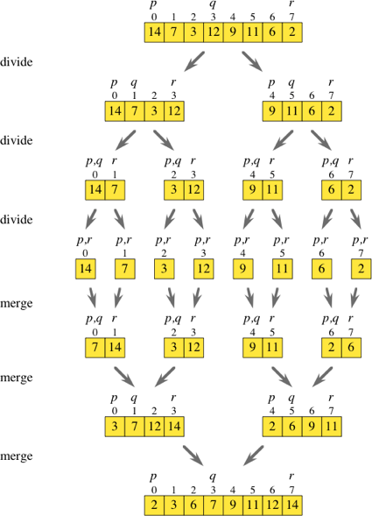

Algorithm

Algorithm MERGESORT (low, high)

// a (low: high) is a global array to be sorted.
{
if (low < high)
{
mid := (low + high)/2 //finds where to split the set

MERGESORT(low, mid) //sort one subset

MERGESORT(mid+1, high) //sort the other subset

MERGE(low, mid, high) // combine the results
}

}

Algorithm MERGE (low, mid, high)

// a (low : high) is a global array containing two sorted subsets
// in a (low : mid) and in a (mid + 1 : high).
// The objective is to merge these sorted sets into single sorted
// set residing in a (low : high). An auxiliary array B is used.

{

h :=low; i := low; j:= mid + 1;

while ((h < mid) and (J < high)) do

{

if (a[h] < a[j]) then

{

b[i] := a[h]; h := h + 1;

}
else
{

b[i] :=a[j]; j := j + 1;

}

i := i + 1;

}

if (h > mid) then

for k := j to high do

{

b[i] := a[k]; i := i + 1;

}

else

for k := h to mid do

{

b[i] := a[K]; i := i + l;

}

for k := low to high do

a[k] := b[k];

}

